3/7/2022

Nupur Sikka

EISYSTEMS

Project Report

Nupur Sikka

**TABLE OF CONTENTS**

|  |  |  |
| --- | --- | --- |
| **S.No** | **Particulars** | **Page No** |
| **1** | **Offer Letter** | **3** |
| **2** | **Acknowledgement** | **4** |
| **3** | **About Institute** | **5** |
| **4** | **Nomenclature** | **6** |
| **5** | **Project Summary** | **7** |
| **6** | **Abstract of Project** | **7** |
| **7** | **Objectives of project** | **8** |

|  |  |  |
| --- | --- | --- |
| **8** | **Process Developed** | **9** |
| **9** | **System Requirement** | **10** |
| **10** | **Screenshots** | **11** |
| **11** | **References** | **12** |

**List of Figures**

|  |  |  |
| --- | --- | --- |
| **S.no** | **Figures** | **Page No.** |
| **1** | **Offer Letter** | **3** |
| **2** | **Logo** | **6** |
| **3** | **e-learning** | **8** |
| **4** | **Process developed and Tim Berners Lee** | **9** |
| **5** | **Screenshots** | **11** |

**Offer letter**

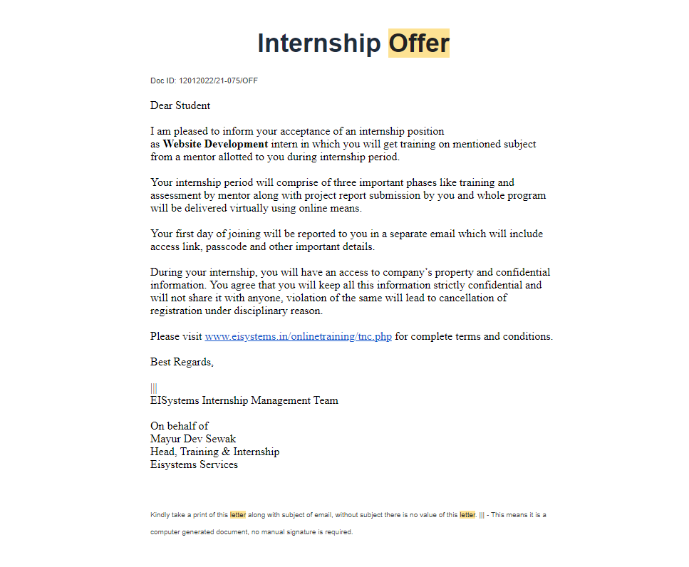

# Acknowledgement

I, Nupur Sikka would like to convey my gratitude to the Company of **EISYSTEMS SERVICES**. For emphasizing on the 6-weeks Internship and giving me the platform to interact with a project team and explore new technology.

I would also like to thank **Mr. Mayur Dev Sewak(General Manager, Operations)**  **Mr. Sushant Srivastav(Trainer, ICT Domain, Logicpro Infosystems)** to work on the project .

I extend my warm gratitude and regards to everyone who helped me during my internship.

# . About the Organization

**EISYSTEMS SERVICES**

# **About EISystems**

**India's leader in workshops & trainings at IITs, NITs & top engineering colleges**  
  
EISystems Services is a leading Indian technology identity with operations across India. EISystems (We call it EISys) offers trainings in Cybersecurity, Machine Learning, Automobiles, Internet of Things, Robotics and Socialmedia for enterprises and student community. Till date we have trained approximately 50000 students and impacted around 2 lakhs students through our various outreach initiatives since our founding.  
**Our Presence**

**Some of the colleges where we had already felt our presence are given below:-**Indian Institute of Science, Bangalore  
Indian Institute of Technology, Bombay  
Indian Institute of Technology, Delhi  
Indian Institute of Technology, Madras  
Indian Institute of Technology, Kanpur  
Indian Institute of Technology, Roorkee  
Indian Institute of Technology, Guwahati  
Indian Institute of Technology (Banaras Hindu University), Varanasi  
Indian Institute of Technology, Indore  
Indian Institute of Technology, Jodhpur  
Indian Institute of Technology, Hyderabad  
National Institute of Technology, Tiruchirappalli  
National Institute of Technology, Warangal  
National Institute of Technology, Calicut  
National Institute of Technology, Patna  
National Institute of Technology, Jalandhar  
National Institute of Technology, Jaipur  
National Institute of Technology, Durgapur  
National Institute of Technology, Surat  
National Institute of Technology, Allahabad  
Indian Institute of Information Technology, Allahabad  
ABV Indian Institute of Information Technology, Gwalior  
PDP Indian Institute of Information Technology, Jabalpur  
Jawahar Lal Nehru Technological University, Hyderabad  
College of Engineering, Guindy Delhi Technological University, New Delhi & around 100 engineering colleges.

**Nomenclature of task**

**My venture call is iEducate - Transforming the world..**

The world is getting online nowadays, people will research new capabilities to grow in terms of development. The web site which I worked on is online training in order that human beings can learn and increase new skills like learning French and German language.

**Why learning a brand new language is essential?**

Mastering a new language pushes your brain to get familiar with new grammar and vocabulary rules. It allows you to educate your memory to retain new words, make connections between them, and use them in contextual situations.

We have brought coding abilities to examine. As in line with state-of-the-art situation, technology is developing swiftly. People are inherently technological beings or device customers. Generation has simply come to be a central a part of the human circumstance – for better and worse. There are some more languages to be delivered at the side of some extra competencies like cooking, image designing and many others.

**Changing getting to know for the better**

Whether or not you need to examine or proportion what you know, you’ve come to the proper location. As a worldwide destination for on-line mastering, we join people through expertise.



Logo of my website ( <https://images-na.ssl-images-amazon.com/images/I/31vc5u2v9RL._SX331_BO1,204,203,200_.jpg> )

**Abstract of the Project**

Gaining knowledge of is part of life. We study some thing every day in our lives, and therefore this web page will help you learn special skills that will help you in your day by day lives.

This web page will introduce extra talents.

So what are you awaiting. Go fill the form and register your self for the courses you want.

STAY TUNED!

**Project Summary**

**My venture call is iEducate - Transforming the world.**

Now the arena is getting on-line these days, humans will studies new abilities to grow in phrases today's improvement. The internet website online which I worked on is online schooling simply so people can study and boom new such things as trendy using python, Arduino etc.

Why modern day a trendy language is crucial?

contemporary a brand new language pushes your brain to get acquainted with new grammar and vocabulary on-line. It permits you to train your memory to don't forget new phrases, make connections among them, and use them in contextual situations.

There are some extra languages to be introduced on the side latest a few greater competencies like cooking, photograph designing and plenty of others.

**Converting brand new for the higher**

You want to study or proportion what you already know, you’ve come to the right region. As a global destination for getting to know modern, we join human beings through information.

**Objectives of project**

The predominant desires of eLearning

Beautify the first-class of mastering and coaching. Meet the getting to know style or wishes of students. Enhance the performance and effectiveness. Improve user-accessibility and time flexibility to have interaction novices inside the studying process. Clean gaining knowledge of goals have to be smart (unique, measurable, action-orientated practical and Time-certain). As soon as you have got evolved your learning targets , it's miles essential to check and ensure that they're all clever.



E-learning( <https://www.simplilearn.com/ice9/free_resources_article_thumb/Why_E-Learning_Insights_into_the_World_of_Online_Learning_and_Development.jpg> )

**Process Developed**

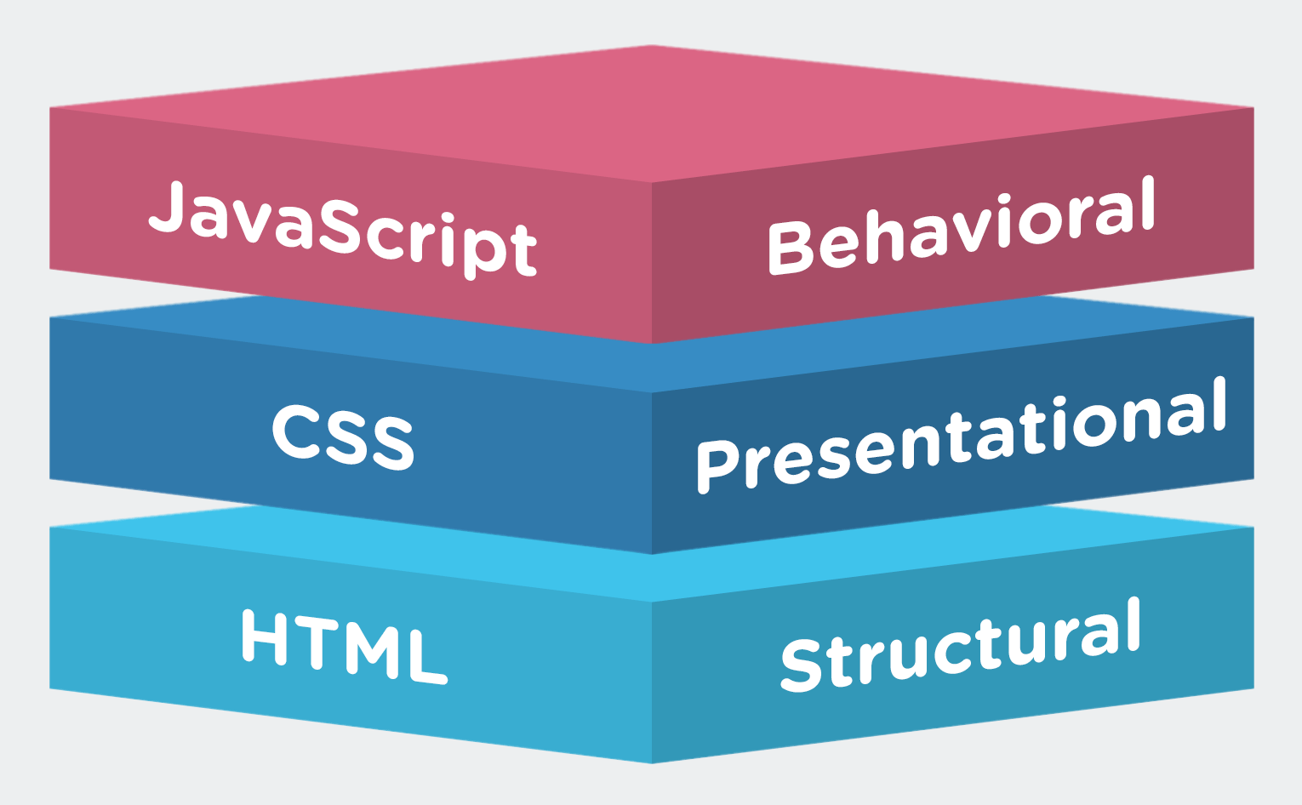

Fig1 ( <https://s3.eu-west-2.amazonaws.com/1training.org/wp-content/uploads/2017/10/18232806/6.png> )

Fig2: Tim Berners-Lee( <https://cdn.britannica.com/22/221822-050-3B0A657F/British-scientist-Tim-Berners-Lee.jpg> )

**Tim Berners-Lee**, a British scientist, invented the arena huge web (WWW) in 1989 at the same time as operating at CERN. The web was at first conceived and developed to satisfy the demand for computerized information-sharing among scientists in universities and institutes around the arena.  
**What's Web?**  
A collection of information accessed via the net through HTTP. Internet makes use of browsers to get admission to documents and net pages. Navigation to others pages arise through hyperlinks.  
To create a fundamental internet page HTML, CSS, JavaScript is used.  
HTML stands for HyperText Markup Language. It presents the fundamental structure of web sites, that's more desirable and changed by way of different technology like CSS and JavaScript. CSS is used to control presentation, formatting, and layout. JavaScript is used to control the conduct of different factors.  
**How do HTML CSS and JavaScript work collectively?**  
HTML is essentially used to write down content material, in different words, it's a markup language.  
CSS stands for Cascading Style Sheets. It's far used to style the consumer interface. Basically, it designs and adjust how the page will appear.  
Each HTML and CSS can form a static internet page. Static way there may be no communication among the internet site and the vacationer.  
JS stands for JavaScript .JavaScript boom the interplay of user and the webpage. indicators, activates are common place in JavaScript. JavaScript can take user inputs and make more responsive.

**System Requirement**

Basic requirements for web development:

* Text Editor(VS Code)
* Enough knowledge of Hyper Text Markup Language or HTML. One should have proper knowledge of HTML tags and attributes.
* CSS for styling a page. HTML without CSS is useless. One should know how to use CSS properly.
* JavaScript is the most important part of web development according to me. JavaScript is used for building logics, and according to these logics your page is going to behave. Moreover, JavaScript is used in front-end development as well as back-end development.
* Browser
* Internet

**Screenshots**



Landing Page

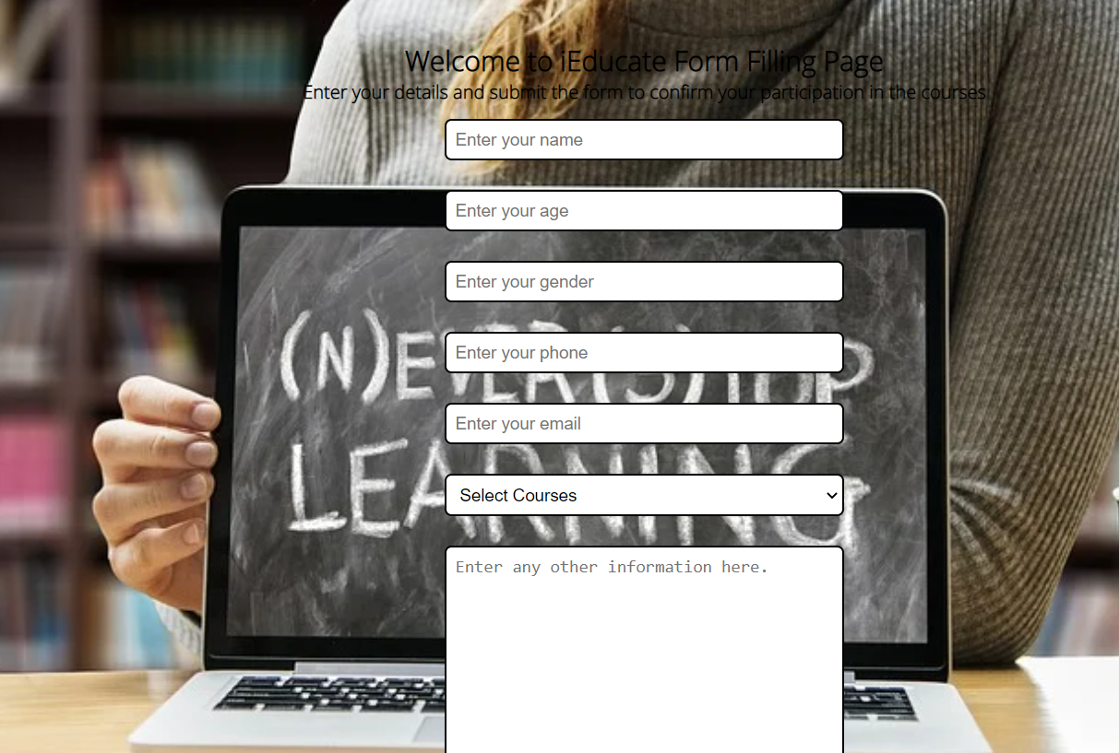

Form page

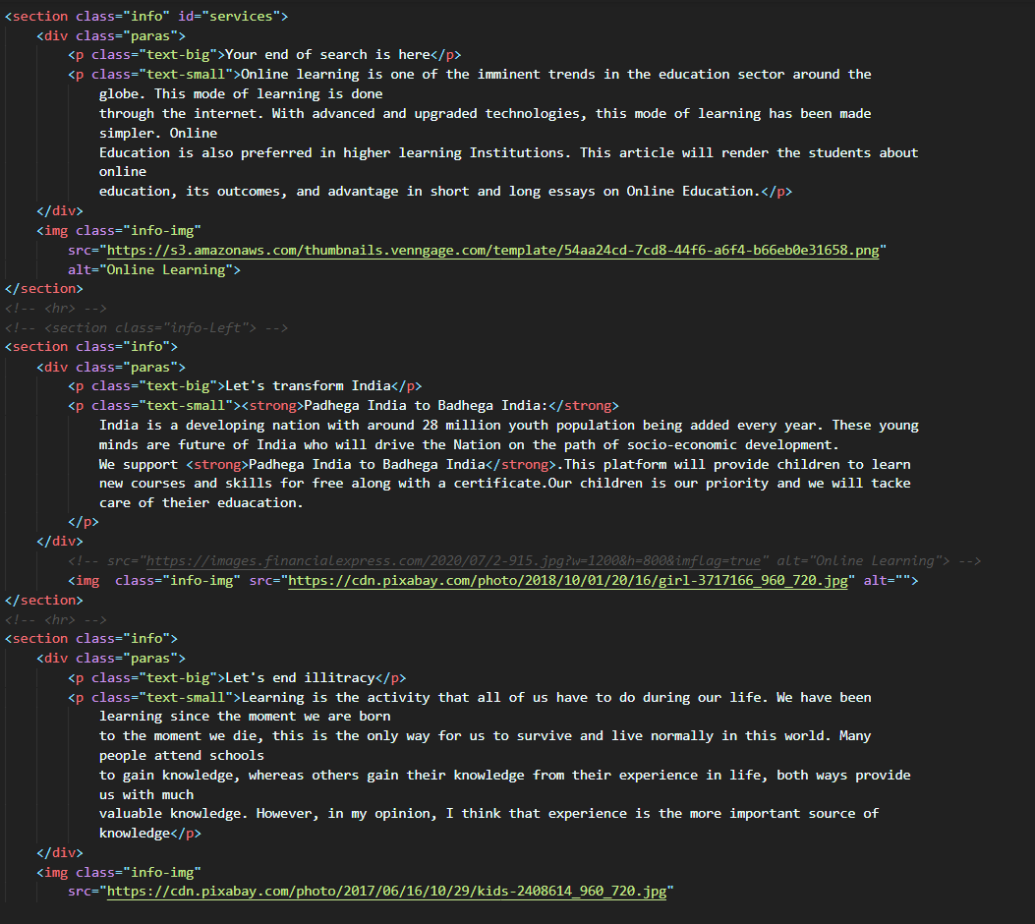

Glimpse of a code

**Project Hosting Link via GitHub**<https://nupur2001.github.io/iEducate-Tranforming-the-world/>

**References**

**Google Fonts:** <https://fonts.googleapis.com/css2?family=Ubuntu&display=swap>

**Logo Image:** <https://www.lovethispic.com/uploaded_images/358039-Think-About-Things-Differently.jpeg>

**Info image(info-img):**

1. <https://s3.amazonaws.com/thumbnails.venngage.com/template/54aa24cd-7cd8-44f6-a6f4-b66eb0e31658.png>
2. <https://cdn.pixabay.com/photo/2018/10/01/20/16/girl-3717166_960_720.jpg>
3. <https://cdn.pixabay.com/photo/2017/06/16/10/29/kids-2408614_960_720.jpg>

**Courses Section:**

1. <https://cdn.pixabay.com/photo/2022/02/13/02/07/retro-7010206_960_720.png>
2. <https://cdn.pixabay.com/photo/2017/03/30/17/43/c-2189150_960_720.png>
3. <https://cdn.pixabay.com/photo/2016/05/08/14/58/icon-1379228_960_720.png>
4. <https://cdn.pixabay.com/photo/2016/07/13/08/48/mobile-phone-1513945_960_720.jpg>
5. <https://cdn.pixabay.com/photo/2017/05/19/21/12/java-2327538_960_720.png>
6. <https://cdn.pixabay.com/photo/2020/03/29/14/32/raspberry-pi-4980917_960_720.jpg>
7. <https://cdn.pixabay.com/photo/2017/08/18/07/52/hands-typing-2654109_960_720.jpg>
8. <https://image.shutterstock.com/image-vector/learn-code-flutter-mobile-ui-600w-1302472156.jpg>
9. <https://cdn.pixabay.com/photo/2014/05/07/15/19/django-339744_960_720.png>
10. <https://cdn.pixabay.com/photo/2021/01/30/12/15/excel-5963669_960_720.png>
11. <https://cdn.pixabay.com/photo/2016/11/18/19/01/paris-1836415_960_720.jpg>

**Project Hosting Link via GitHub**

<https://nupur2001.github.io/iEducate-Tranforming-the-world/>